Quartz TT12: Checking Zigzag
Award by Hans Gruber (D-Regensburg), International FIDE Judge

Tourney participants:
- Karol Mlynka (SVK) - 1
- Paul Răican (ROU) - 2, 3, 4
- François Labelle (CAN) - 5
- Sébastien Luce (FRA) - 6
- Arnold Beine (GER) - 7, 8, 9, 10, 13
- Michel Caillaud (FRA) - 11, 12

It was an exciting rediscovery of Paul Răican when he published the article about checking zigzag in Quartz 45 (June 2018). Checking zigzag had been very popular in particular in the post-WWII years when for example FEENSCHACH was launched. Later the condition fell into oblivion – when I tested a number of Wenigsteiner (minimanner) problems in the 1980ies, I learned to know why: they were unexpectedly vulnerable to quite surprising cooks!

Therefore it is an excellent idea to rediscover Zigzag now, when powerful testing programs are available. As Paul mentioned, in particular WinChloe offers testing possibilities for a number of varieties of the condition. One of the drawbacks of the original version of the condition has been its unnatural restriction of white moves – which again and again was criticised, and new definitions were proposed. Unfortunately, some of them used the same label for different versions. I remember that Jörg Kuhlmann almost 40 years ago drafted a manuscript in which he wanted to analyse systematically those different variations. The planned title of the text was charming. Unfortunately it is a German play on words: “Zickzack und Zwickzwack”. The deserving presentation of the conditions in the Quartz article might inspire Jörg to resume (and finally publish) his work? I briefly summarise the definitions.

Checking zigzag (Schachzickzack)
- Black moves only to check (if no check is available, Black does not move).
- White must not capture (unless no other legal move is available).
- White must not check. This offers the possibility of fairy mates and fairy stalemates.

Ultra checking zigzag (Ultraschachzickzack)
- Black moves only to check (if no check is available, Black does not move).
- White must neither capture nor check. This offers the possibility of fairy mates and fairy stalemates.

Black moves only to check (Schwarzschächer; les Noirs ne jouent que pour donner échec)
- Black moves only to check (if no check is available, Black does not move).
- No restrictions of white moves.

Checking zigzag type Stapff (Schachzickzack Typ Stapff)
- Black moves only to check (if no check is available, Black does not move).
- White must neither capture nor check (unless no other legal move is available). This excludes the possibility of fairy mates and fairy stalemates.

Eric Huber acted as tournament director of the Quartz TT12. At the submission date (March 1st, 2019), he had received 13 entries which he promptly forwarded to me in a standard format, nicely prepared (one diagram per sheet, comments translated into English when necessary, anonymised diagrams).

Unfortunately the overall level of the tournament was not very high – it was lower than the level in the old problems published in the article! In some proof games, either additional fairy chess conditions were not well explored, or the contents were not ambitious (please compare with orthodox proof games). Problems from other genres (#2, S#11, !=15) used coarse moves, uneven twinning, or showed little harmony and depth.

There were a number of new ideas, however, so that I am convinced that this tournament is a first step in a longer process of rediscovering the zigzag condition. As usual nowadays (and strongly supported by the new testing program Jacobi), the genre of proof games was used a lot. Eight of the 13 entries were proof games (more than 60 per cent). Some belonged to the same “family”. I included five problems in the award which may seem to be a small number, but at the same time it is a large percentage (almost 40 per cent)!

Prize: Michel Caillaud (France)

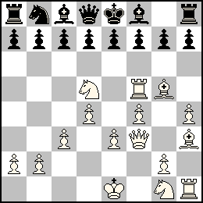
(16+15) PG 31
Checking Zigzag
Roque

1.Sc3 2.Sd5 3.c3 4.Qa4 5.Qh4 6.d4 7.Bf4 8.Rd1 9.Rd3 10.Rh3 11.e3 12.Ke2 13.Kf3 14.Kg4 Sh6+ 15.Kf3 16.Ke2 17.Ke1 18.Be2 19.Bg4 20.f3 21.0-0 [Kg3, Qf2] Sf5+ 22.Bxf5 23.Rh5 24.h4 25.Bh3 26.Rf5 27.Bg5 28.f4 29.Qf3 30.Kf2 31.Ke1

Would only this problem have been submitted, the tournament would have been a success! What a surprising (long) solution with two switchbacks of the white king after long marches. This is spectacular in a problem that resembles a series proof game. The problem demonstrates a perfect usage of the extra condition – with a good understanding of economy: It is not quantity that counts but quality! This is shown by the author’s remark “No other castling than the thematic one”.

There is one problem with the black homebase position – what happened to the missing knight g8? Obviously it must have been captured when White had no other legal move – given the mobility of white pieces it is clear that the knight checked just before it was captured. What the hell was the white move before Black checked? If the king would already have been on its square, Black had had to check previously. If the last move was a move by the king, White has the option to return the king rather than to capture (so the capture is not legal). If the white king entered its square from an extra flight that is covered by the knight, then the knight had had to check previously as well. The only solution to this dilemma is a fairy castling which simultaneously blocks the king’s last flight! Everything is focussed on this queen of the moves, 21.0-0 [Kg3, Qf2]!!

Let’s hope that this problem remains correct. Theoretically it is possible to construct a proof game with only one switchback of the white king: capturing the bS at f6, with wKg4, wBf3, wQh6 – to prevent the check h7-h5+ after wBg5xbSf6. Paradoxically this takes longer than the solution, for instance:
1.Sc3 2.Sd5 3.c3 4.d4 5.Qd2 6.Qh6 7.Bg5 8.Rd1 9.Rd3 10.Rf3 11.Rf5 12.f4 13.e3 14.Se2 15.Sg3 16.h4 17.Rh3 18.Be2 19.Bh5 20.Ke2 21.0-0 [Kg4, Bf3] Sf6+ 22.Bxf6 23.Se2 24.Sg1 25.Kg3 26.Kf2 27.Ke1 28.Rh1 29.Bg4 30.Bh3 31.Bg5 32.Qh5 33.Qf3

Honourable Mention: Arnold Beine (Germany)

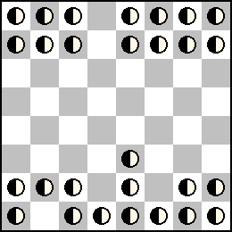
28 unspecified pieces
Position after the 6th white move, Black is mate
Schwarzschächer
Annan Chess
Chameleon Chess
C+ Jacobi
Author comments:  Analysing the diagram position it is obvious that bK is still on e8 (could move only when checking). Black's possible checks are d7xd2+ and afterwards Qd8-d3=S+. Both squares are vacant, so one can assume that both black pieces were captured (4 pieces are missing), also wPd2 and the last missing piece could be captured in the mating move, e.g. Qxc7=S#. This leads to the - unique! - "solution"  1.fe3 dxd2+ 2.Sxd2=B Qd3=S+ 3.Bxd3=R 4.Rd6=Q 5.Qxc7=S#  But this is only a try, because the "solution" is too short - "after the 6th move" was required.  How can White win a tempo? Chameleon Chess disturbs every simple tempo move like 4.Rd5?? 5.Rd6=Q. So White has to change the whole system: the piece, making the key in the try, mates; the mating piece in the try helps pinning in the solution and the bS is captured by another wB.  1.ee3 dxd2+ 2.Sxd2=B Qd3=S+ 3.Bfxd3=R 4.Rf1=Q! (switchback) 5.Be2=R 6.fxf7# (6...exf7??) | Try in 4.5 moves:  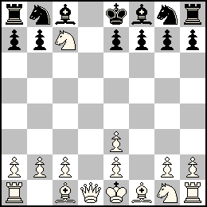  Solution in 5.5 moves:  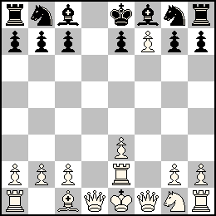

A very good “try” (“too short solution” – I am not sure whether the stipulation should include the word “exactly” in order to avoid that somebody claims that the try is a cook), with much variation compared to the solution. Both phases use the extra conditions (Annan Chess, Chameleon Chess) in a number of moves which makes this problem superior to other submissions with unspecified pieces. Those suffered from the fact that in their 1-phase solutions the usage of the extra conditions was dissatisfactory.

1st Commendation: Arnold Beine (Germany)

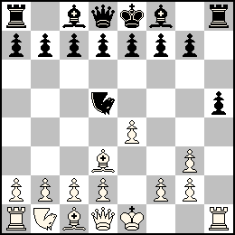
(15+15) PG13.5
Schwarzschächer
N=Cavalier Majeur (N)
C+ Jacobi

1.e4 2.Bd3 3.Ne2 4.O-O Nxe2+ 5.Kh1 Ng3+ 6.hxg3 7.Kh2 Nf6+ 8.Kh3 Nd5+ 9.Kg4 h5+ 10.Kf3 Nh7+ 11.Ke2 12.Rh1 13.Kf1 Nd5+ 14.Ke1

A nice roundtrip although it is obvious, that the king has to enter the square g4. The Cavalier Majeur is nicely used to construct a sound proof game.
2nd Commendation: Sébastien Luce (France)

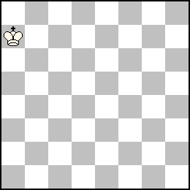
(1+0) 2.1.1... s#15
Checking Zigzag
Sentinelles en Pion adverse
C+ Winchloe
1.Kb7(+bPa7) 2.Kc7(+bPb7) 3.Kd8(+bPc7) 4.Ke7 5.Ke6(+bPe7) 6.Ke5(+bPe6) 7.Ke4(+bPe5) 8.Ke3(+bPe4) 9.Ke2(+bPe3) 10.Kf1 e2+ 11.Kg2 e1=S+ 12.Kh3(+bPg2) g1=S+ 13.Kg3(+bPh3) Se2+ 14.Kh2 Sf3+ 15.Kh1 Sg3(+bPe2)#
1.Ka6(+bPa7) 2.Kb7(+bPa6) 3.Kc8(+bPb7) 4.Kd7 5.Kd6(+bPd7) 6.Kd5(+bPd6) 7.Kd4(+bPd5) 8.Kd3(+bPd4) 9.Kd2(+bPd3) 10.Kc1 d2+ 11.Kb2 d1=S+ 12.Ka3(+bPb2) b1=S+ 13.Kb3(+bPa3) Sd2+ 14.Ka2 Sc3+ 15.Ka1 Sb3(+bPd2)#

A funny Sehr-Wenig-Steiner (one piece only). The chameleon echo manoeuvres and mates in different corners look like a big achievement ... but the problem is much less paradoxical at the second look (instead, rather symmetrical). Nevertheless this is an interesting finding.

3rd Commendation: Paul Răican (Romania), after Dawson and Fox

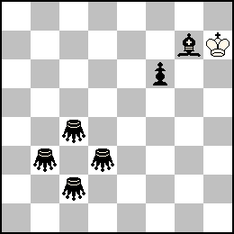
(1+6) s#13
b) auto=10
=Grasshopper
Checking Zigzag
C+ Winchloe
a) 1.Kg8 2.Kf7 3.Ke6 Gd5+ 4.Kf7 Ge6+ 5.Ke8 6.Kd8 7.Kc7 8.Kb6 9.Ka5 10.Ka4 11.Kb3 Gc4+ 12.Ka2 Gb3+ 13.Ka1 f5#
b) 1.Kg6 f5+ 2.Kf7 3.Ke8 4.Kd7 5.Kc7 Be5+ 6.Kc6 Gc5+ 7.Kb7 8.Ka6 Gb5+ 9.Kb7 Gb6+ 10.Ka8 auto=

A wonderful first twin – look how the white king treats the black grasshoppers, chasing them up and down the diagonal just in order to reach the square a1 (short version of the solution: 1.-13.Kh7 jumps to a1, f5#). It is remarkable that a solution exists with a different stipulation, but the twin does not contribute to the contents (it is rather distracting than enriching).

Thanks to the Romanian organisers of this tournament and to all authors who participated, congratulations to the authors of the awarded problems.

Regensburg/Germany, March 6th, 2019
Hans Gruber

❖

Fairy definitions

Annan Chess: Units move normally except when they are standing one square directly in front of another unit of the same color, when they move with the power of the rear unit.

Cavalier Majeur: By default, a Knight is replaced by a Nightrider.

Chameleon: On completing a move, a Chameleon (from classical standard type) changes into another piece, in the sequence Q-S-B-R-Q… Promotion may be to a chameleon at any stage in the cycle.

Chameleon Chess: By default, a Knight is replaced by a Chameleon(S), a Bishop by a Chameleon(B), a Rook by a Chameleon(R) and a Queen by a Chameleon(Q).

Grasshopper: Moves along Q-lines over another unit of either colour to the square immediately beyond that unit. A capture may be made on arrival, but the hurdle is not affected.

Roque: A King can "castle" with any piece, both diagonally and orthogonally, by moving two squares toward it. The other piece is placed on the opposite side of the King. As for the normal castling, the King must not be in check when moving.

Sentinelles: When a piece (Pawn excluded) leaves a square outside the first and last rows, it leaves a Pawn of the colour of the side that played unless 8 Pawns in this colour are already on the board.

Sentinelles en pion adverse: When a piece (Pawn excluded) leaves a square outside the first and last rows, it leaves a Pawn of the colour of the other side unless 8 Pawns in this colour are already on the board.

